

CS5460 – Assignment 4



March 28, 2016

Varun GATTu

A02092613

**Cross site scripting (XSS) attack Lab**

**2. Lab Tasks**

**2.1. Environment Configuration**

To access the ELGG application, we need to first start the apache service like the following screenshot:

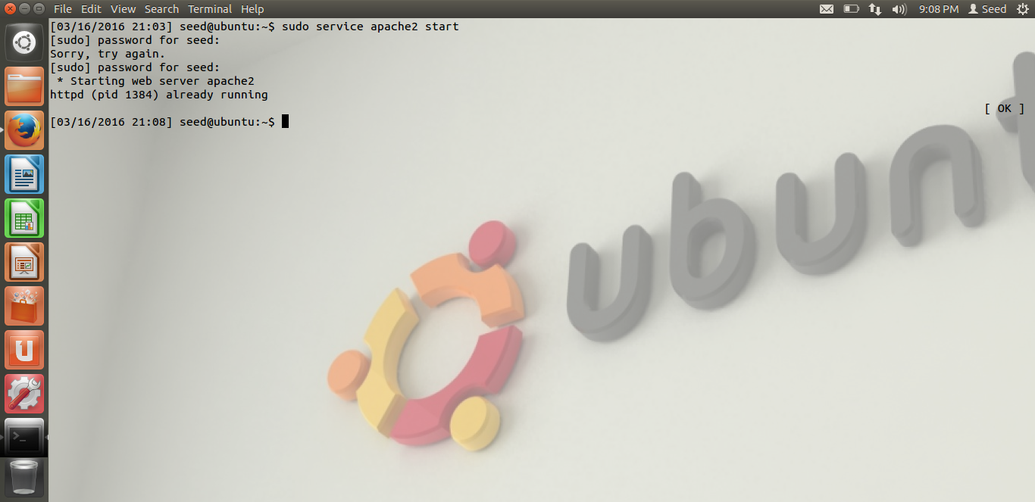

Then, using the manual file, we navigate to <http://xsslabelgg.com/> and login using any of the given credentials to access the following page:

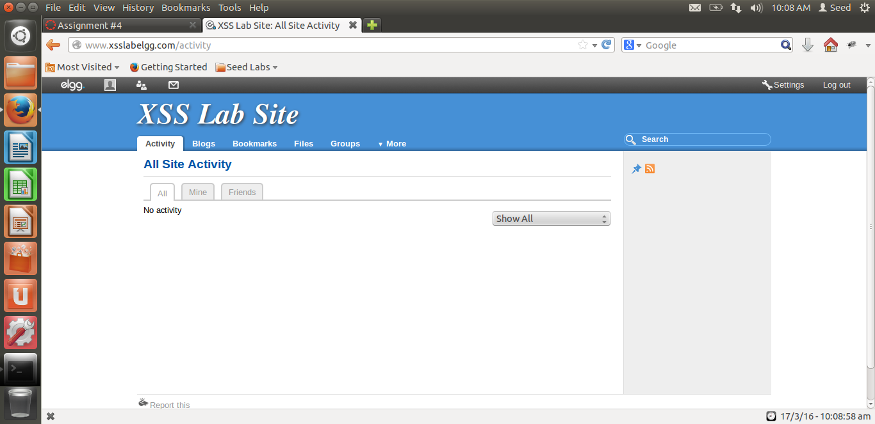

Then we make sure that a virtual host is created for xsslabelgg.com in the /etc/apache2/sites-available folder. The below screenshot shows that it is already setup:

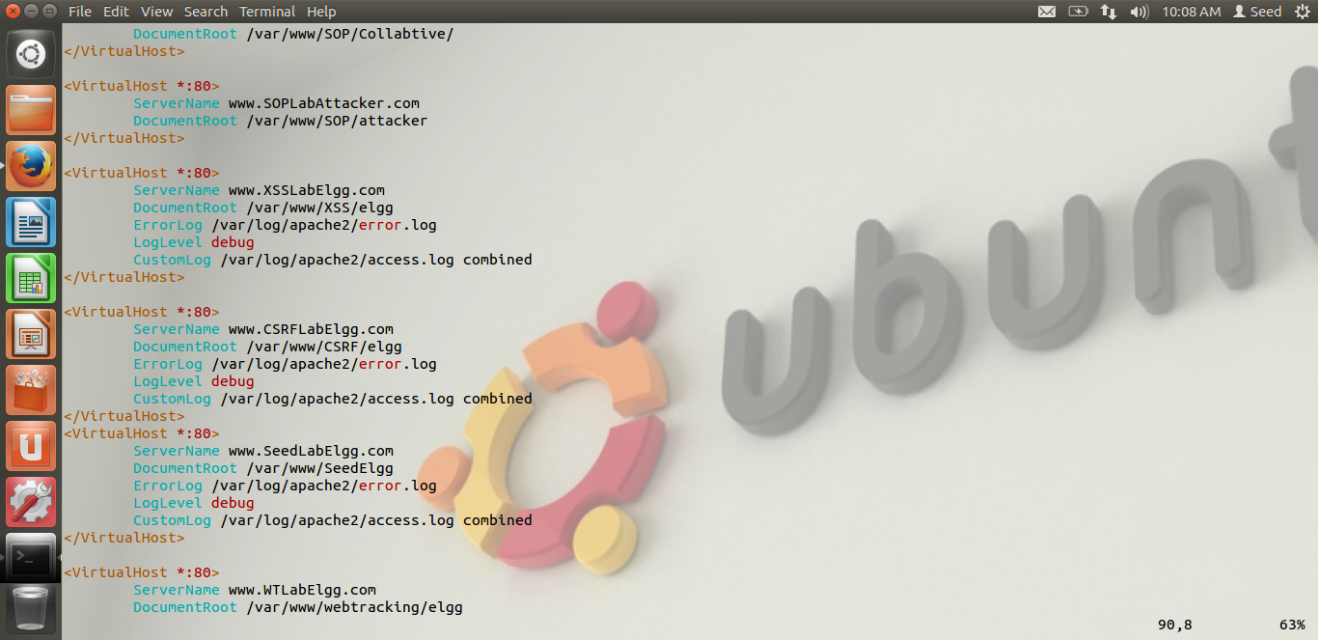

**3. Lab Tasks**

**3.1. Task1: Posting a Malicious Message to Display an Alert Window**

We can perform this task in 2 ways. The first method is by embedding JavaScript program in the Elgg profile as follows:

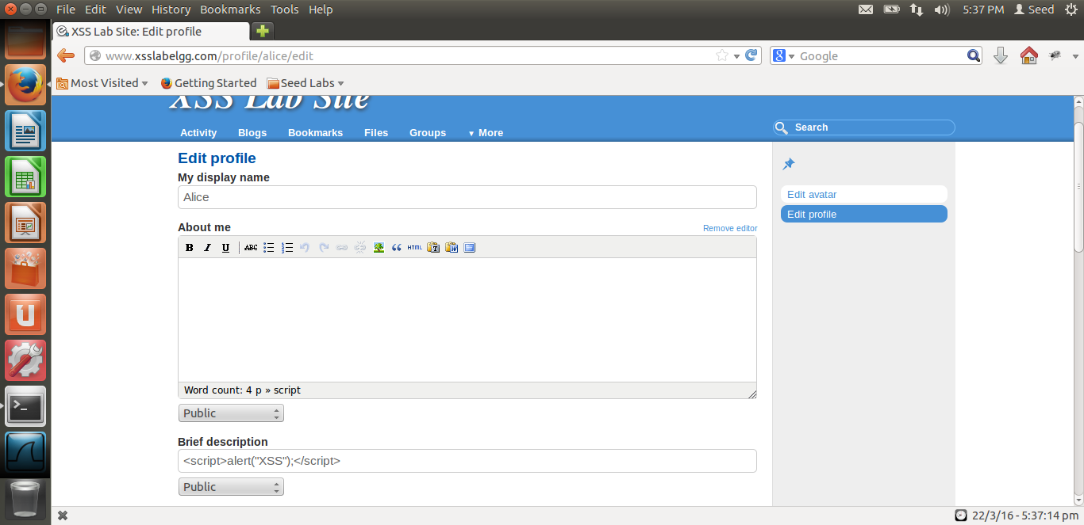

After this, when we navigate to the profile, the following popup occurs:

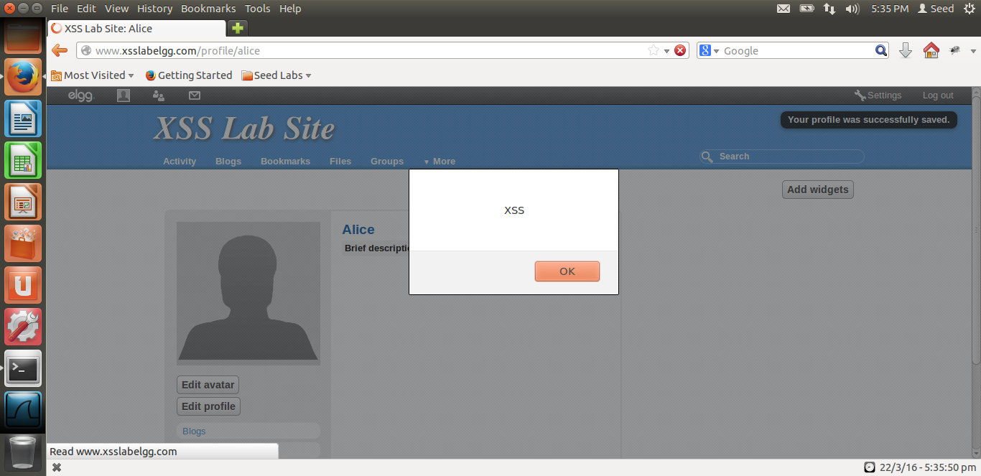

The second way to do this is by save the script information in a separate JavaScript file and link the file in the description as follows:

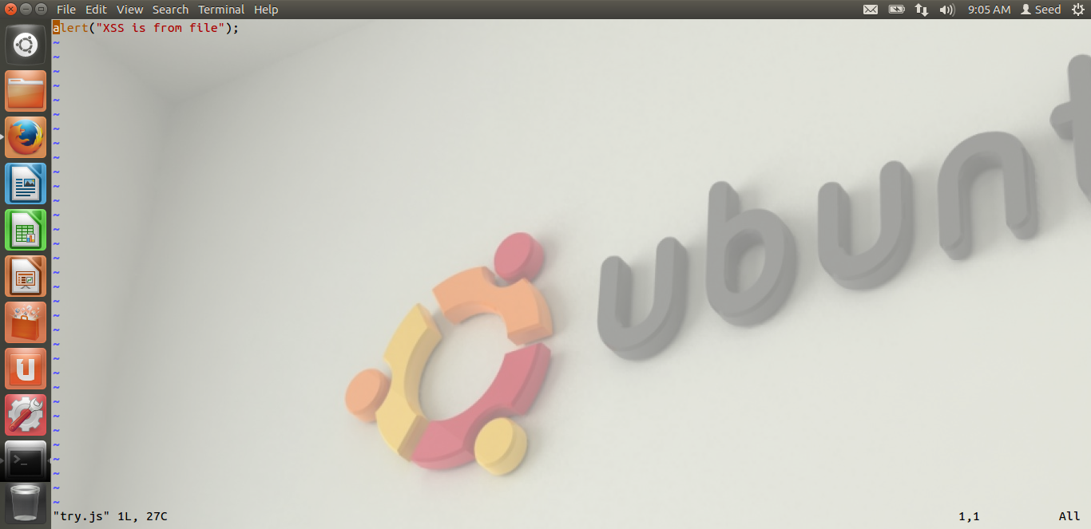

The output will be as follows:

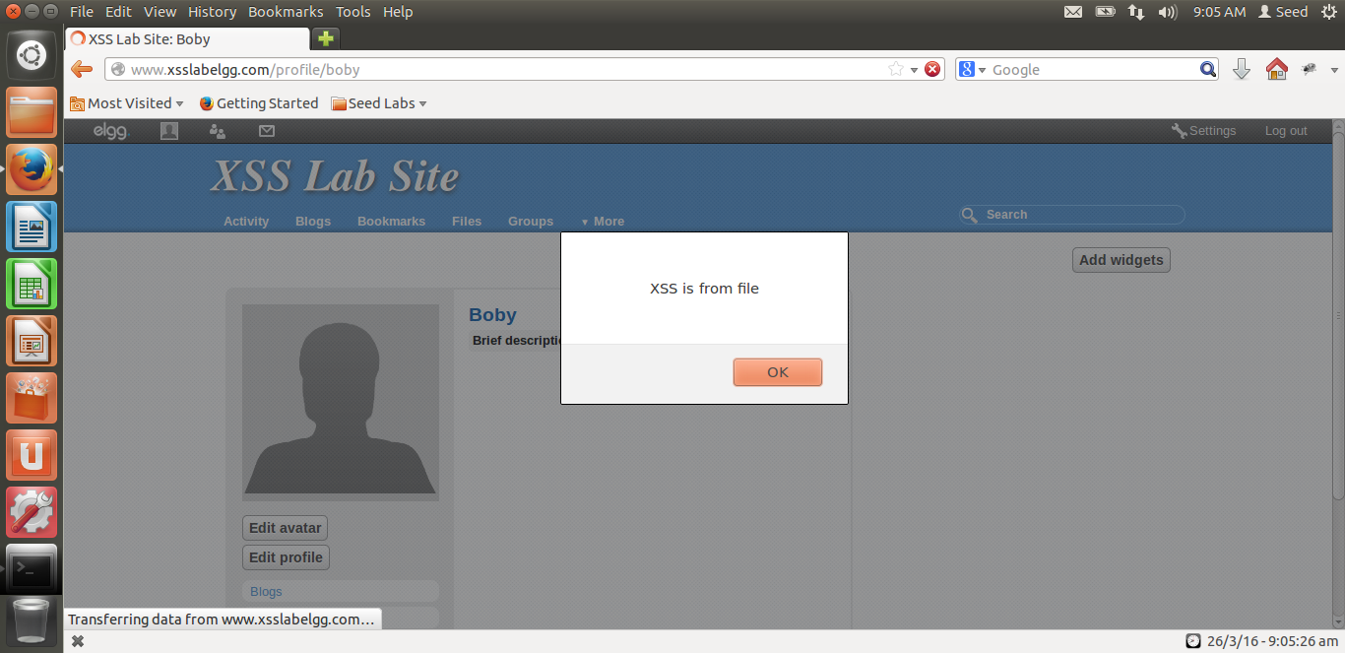

**3.2 Task2: Posting a Malicious Message to Display Cookies**

Now, in this task we need to steal the cookies from the webpage. The cookie value should be displayed as a popup.

The following screenshots show how:

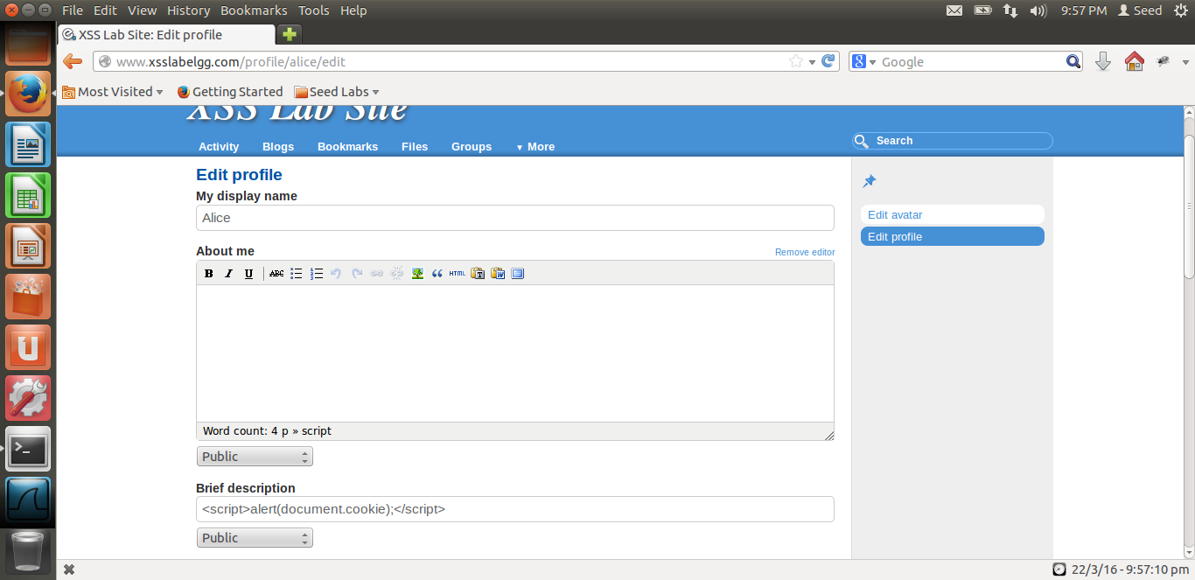

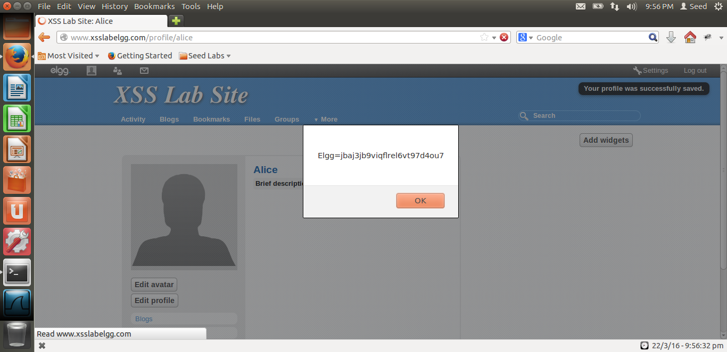

**3.3 Task3: Stealing cookies from Victim’s Profile**

Here, we try to steal cookies from the Victim’s profile by hosting an image on the local host with port# 5555. Then, we embed that in the brief description of the profile like follows:

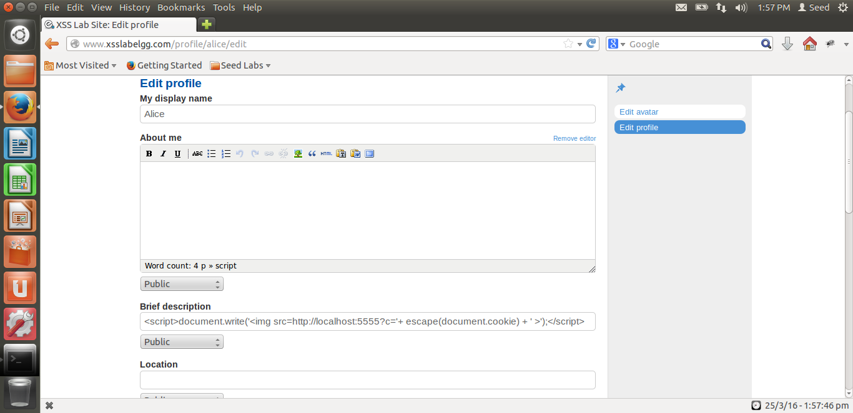

Now, we use the echoserver program and start the server using make command. The next step is to run the echo server program with the port number. Once we start the telnet server, we can echo what we write as follows:

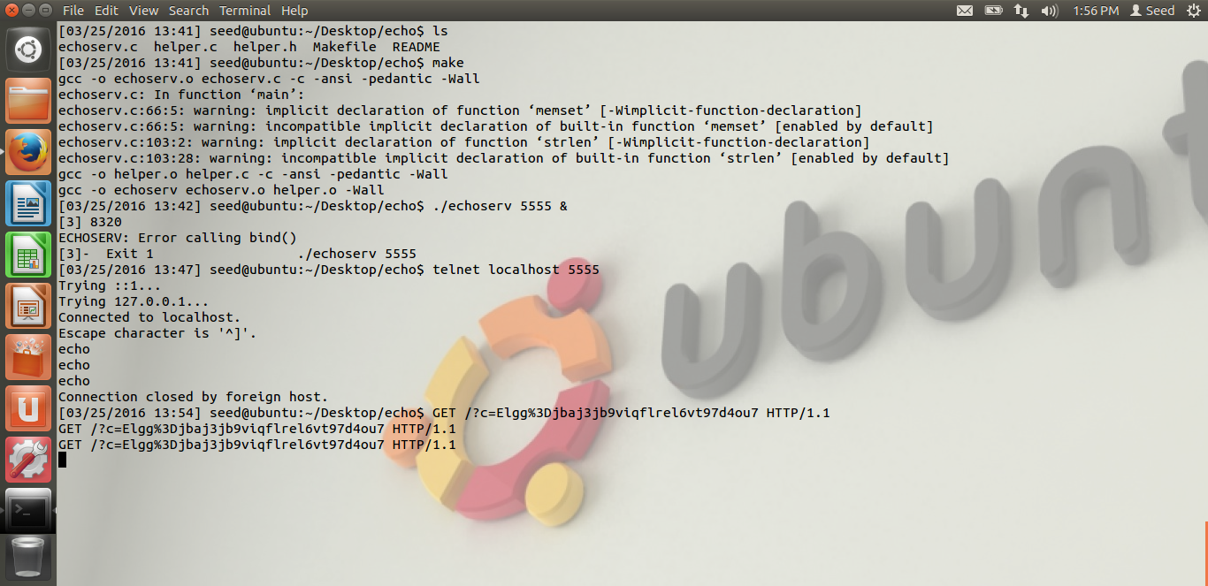

Now, every activity is captured and can be seen in the above image.

**3.4 Task4: Session Hijacking using Stolen Cookies**

Here, we try to Hijack the session using the data from live http headers. In the Java Program HTTPSimpleForge, elgg_ts, elgg_token values are taken from the LiveHTTPHeaders. The URL is obtained when we navigate to Samy’s profile and mouse is hovered over the add friend button. Then, the following commands are added:

setRequestMethod();

addRequestProperty();

String cookie value

setRequestProperty();

The following screenshot shows how it works:

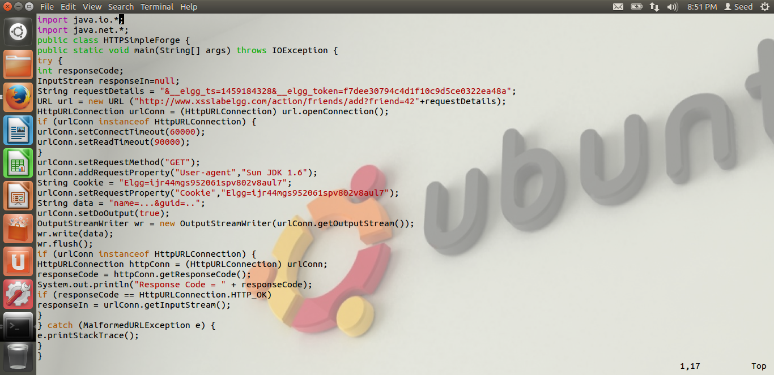

After we run the java program, the response code shows 200 as follows:

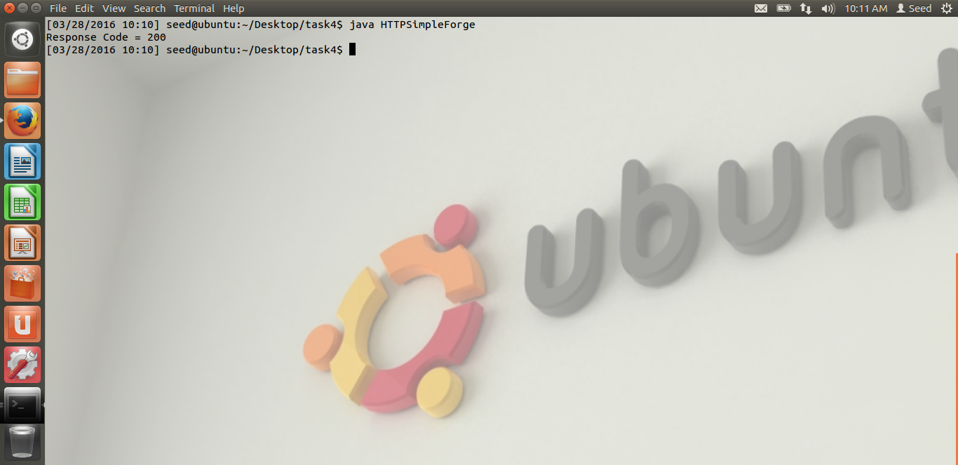

When another profile views Samy’s profile, it automatically adds Samy as a friend to the profile as follows:

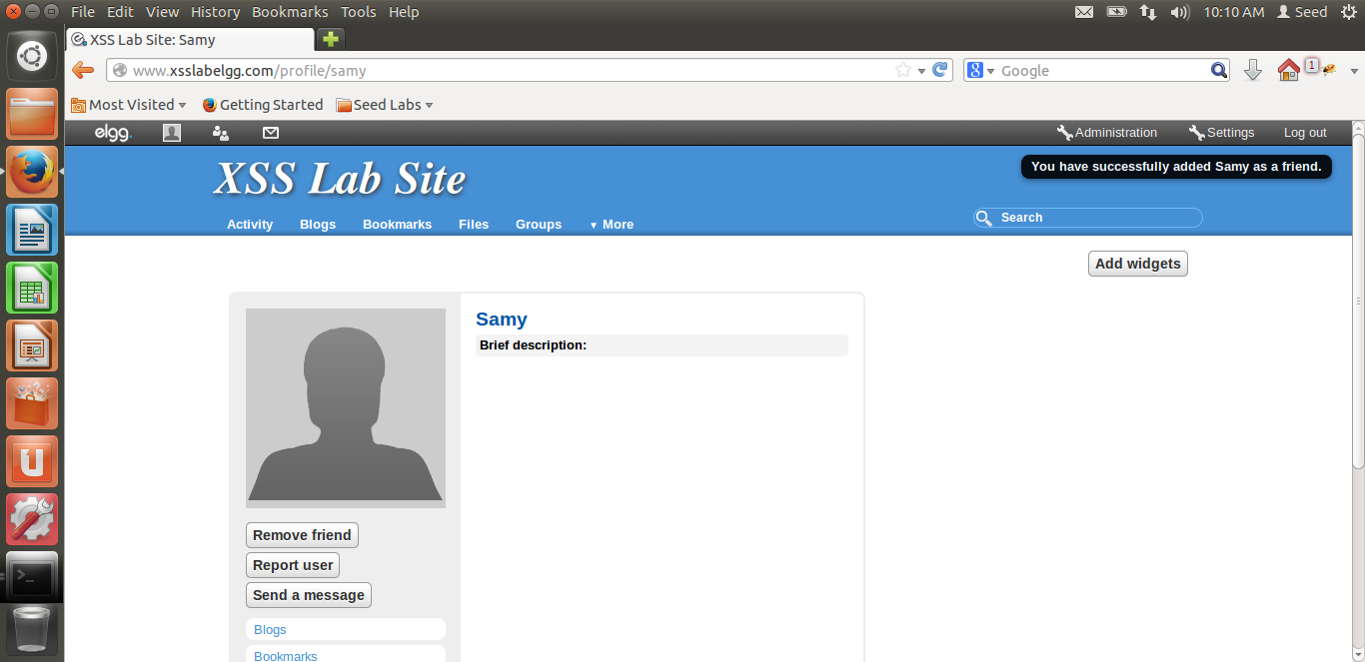

**3.5 Task5: Writing an XSS Worm**

Here, we try to write some AJAX code to do two tasks. The first one is, to add a friend who views the profile automatically. This will be done using the add friend hover, elgg_ts and elgg_token from LiveHTTPHeaders.

The second task is to edit the victim’s profile to include a text on his profile which says “Samy hacked the profile”. This can be obtained using elgg_ts, elgg_token, name, description and guid which can be taken from the source code of samy’s page. This content is sent to the victim’s profile and hence changes its data.

All this can be obtained like the following:

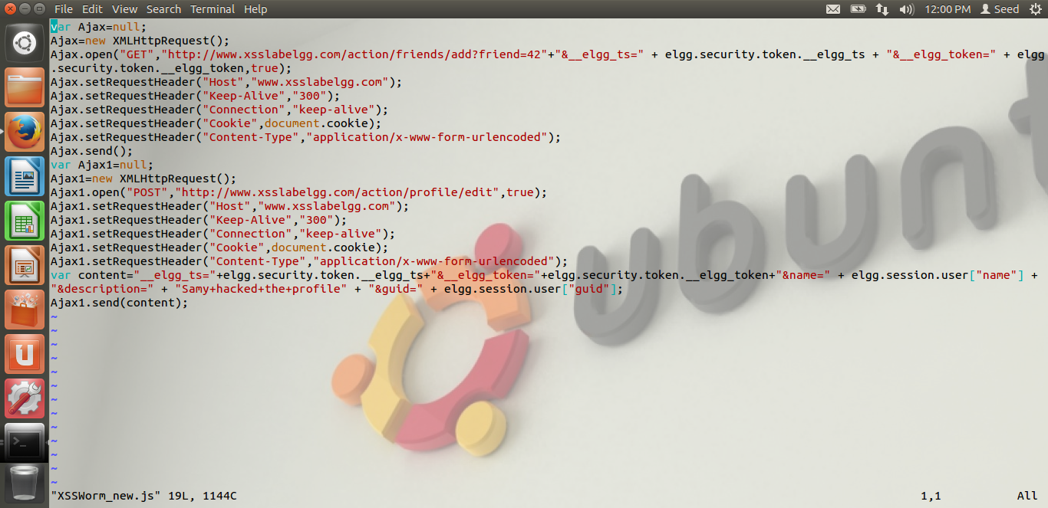

Before this code is embedded in Samy’s profile, boby is not added to Samy as shown here:

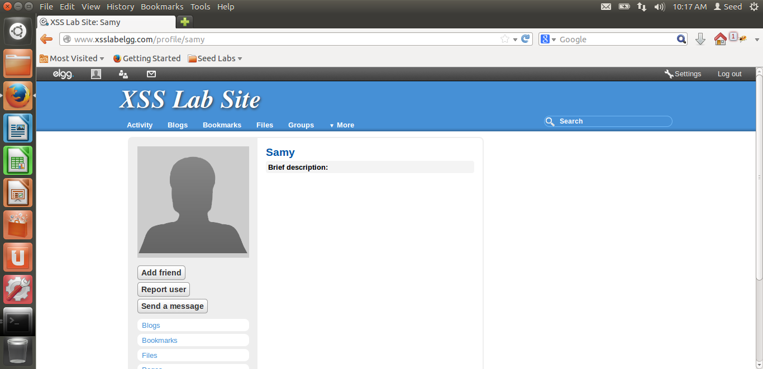

The AJAX code is saved in a JavaScript profile and hosted on the ELGG site. This JavaScript is embedded in samy’s profile and then login with boby’s profile to view Samy’s profile. This is what happens when this is done:

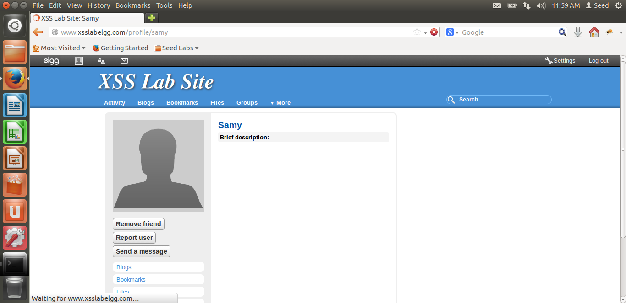

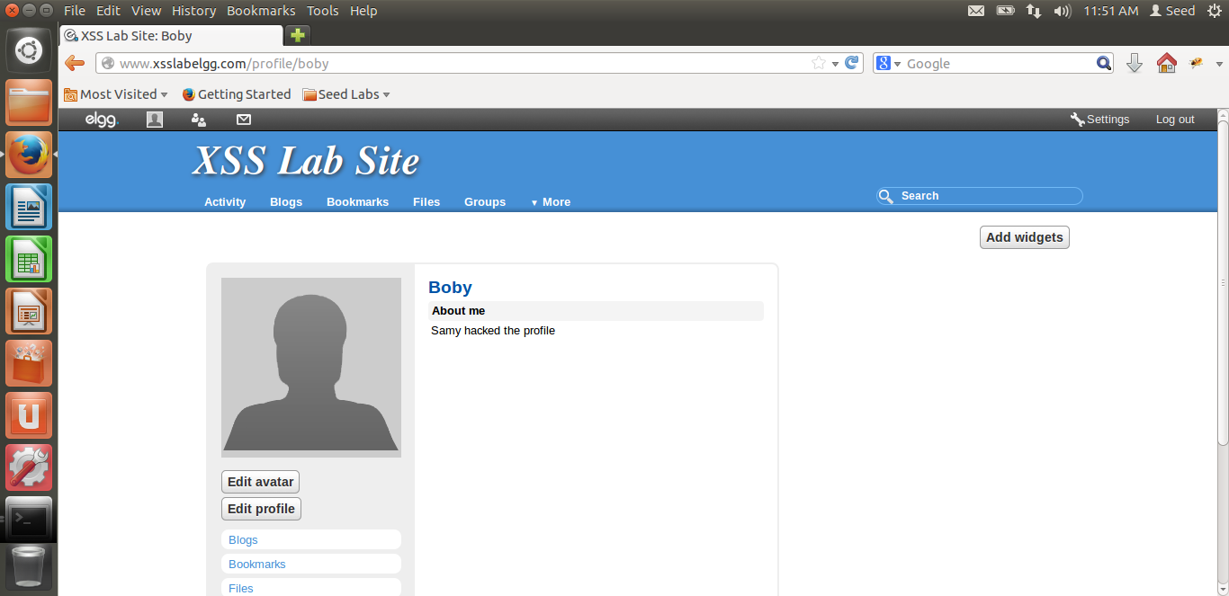

**3.6 Task6: Writing a Self Propagating XSS Worm**

Here, the only change that happens is victim’s profile will be updated with the JavaScript worm and hence makes it self-propagating. This means that, the worm will navigate to every profile that visit’s Samy’s profile and any of the victim’s profile. This worm can let the whole network get effected within no time.

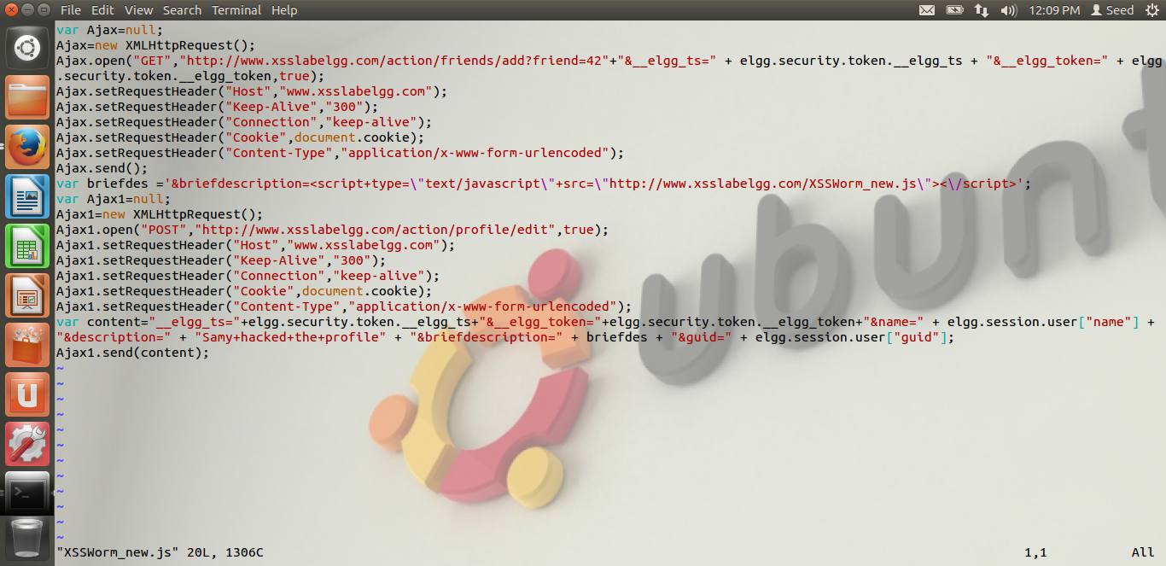

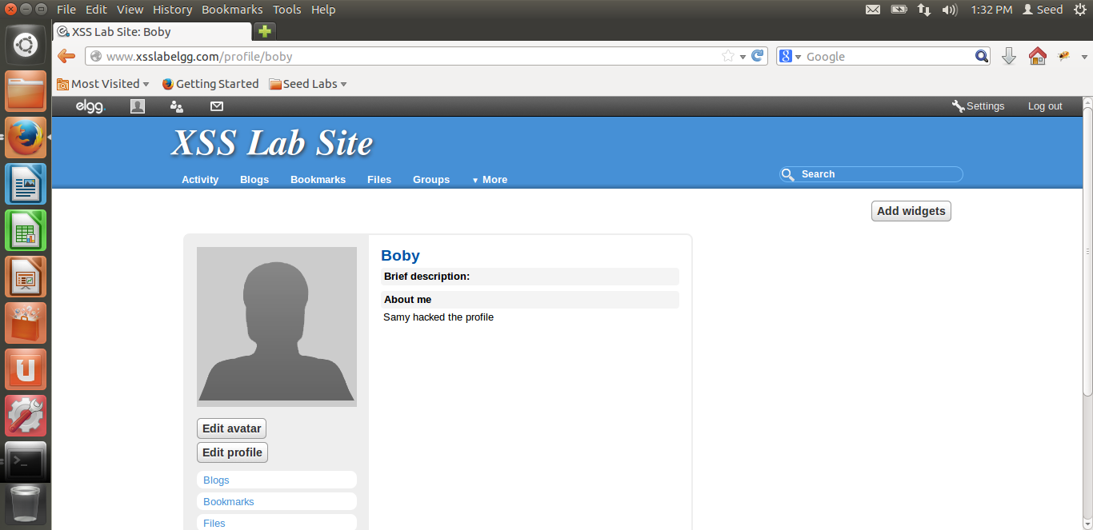

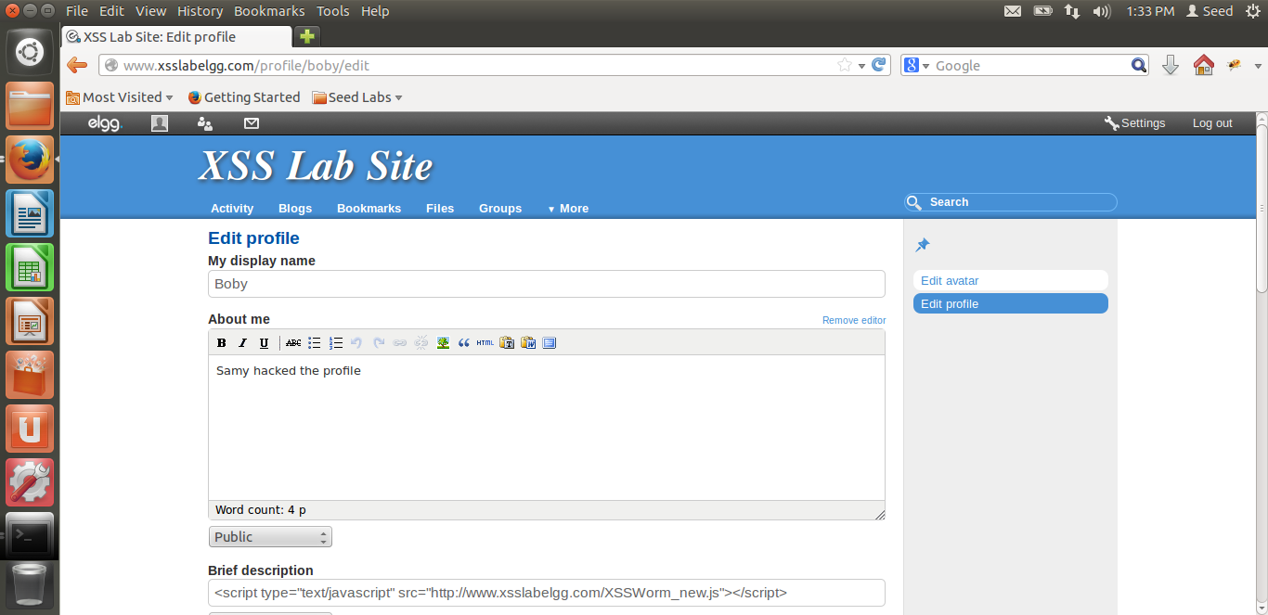

Now, anyone who visit’s Boby’s or Samy’s profile will be infected.

**3.7 Counter Measures**

To avoid all that happened, there are inbuilt counter measures in ELGG. One of them is obtained by activating HTMLawed 1.8 plugin which can be done from admin’s profile as follows:

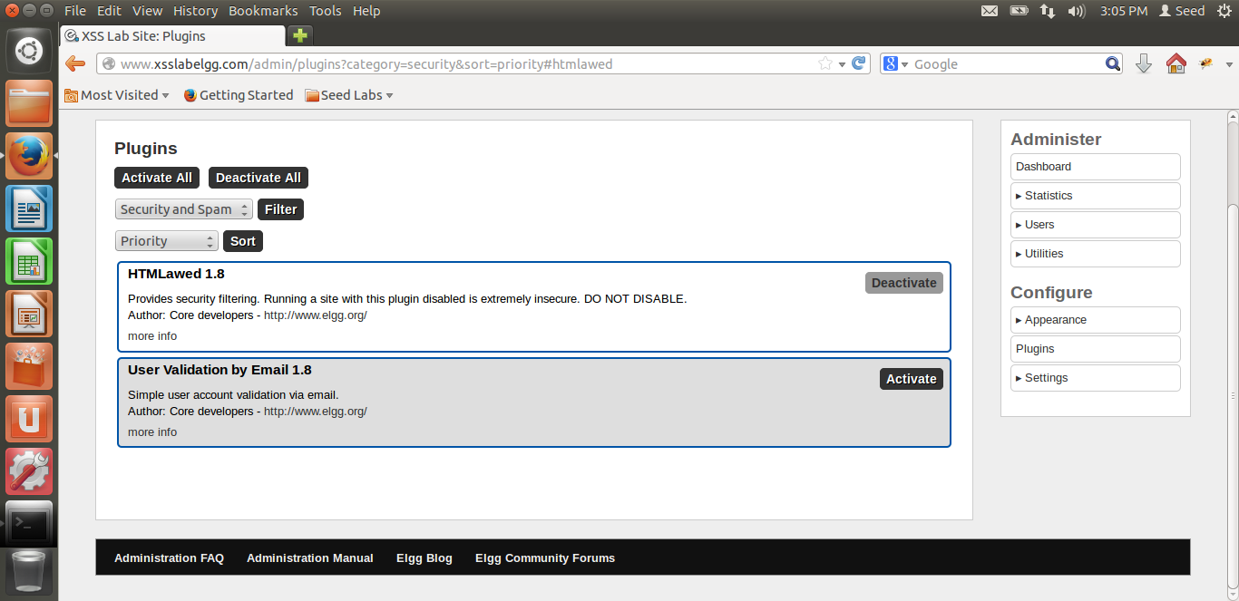

Then, all the htmlspecialchars() should be uncommented from a set of files in elgg/views/default/output like the follows:

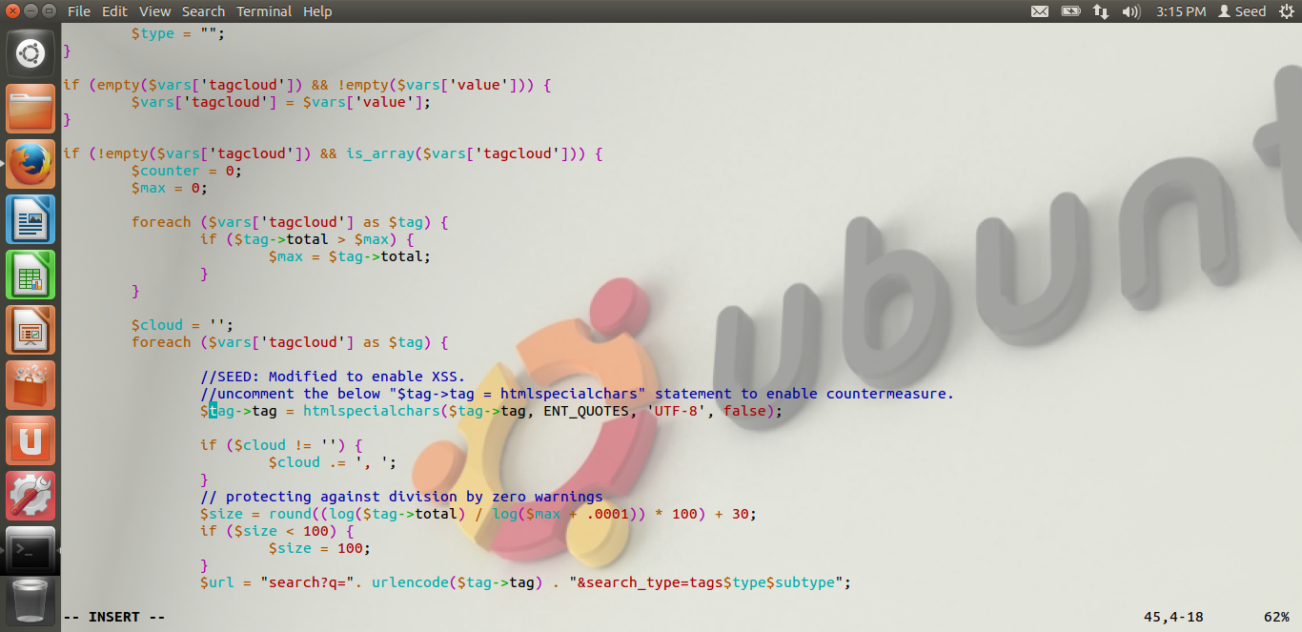

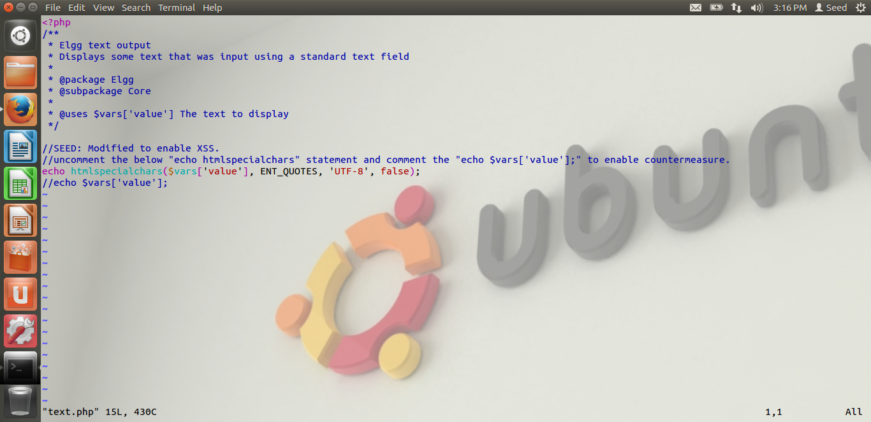

This is repeated for all the below files:

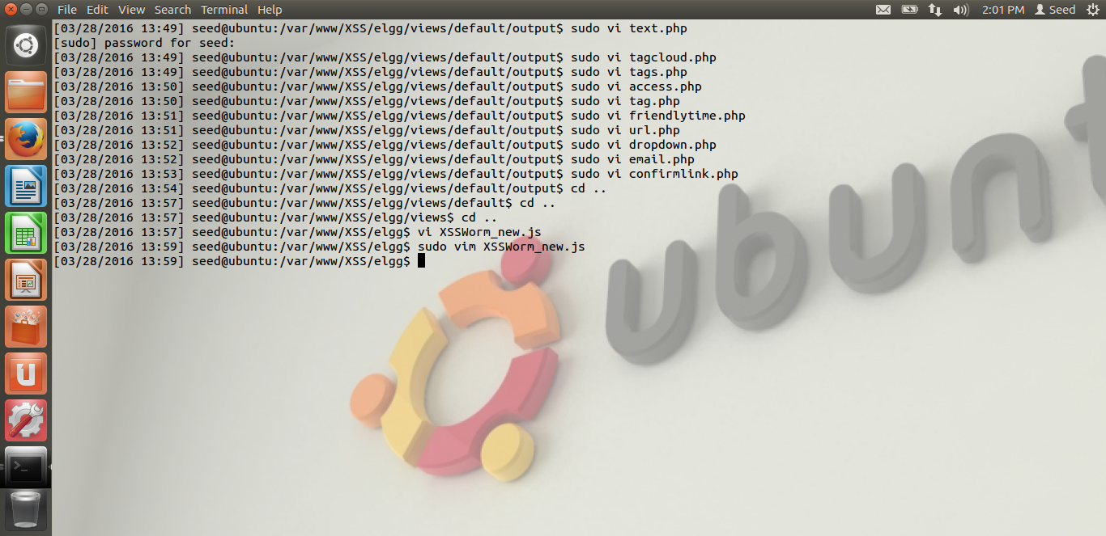

After these counter measures are implemented, we again try to unfriend samy from boby’s profile and then again the script is embedded in samy’s profile. Now, if boby’s profile views samy’s profile, the attack will not happen. All these count measures stop from creating XSS worms.